**DATA BASE & MANAGEMENT SYSTEM**

**(CSX-224)**



**DEPARTMENT OF COMPUTER SCIENCE AND ENGINEERING**

**Dr. B R AMBEDKAR NATIONAL INSTITUTE OF TECHNOLOGY**

**JALANDHAR – 144011, PUNJAB (INDIA)**

**Submitted To: Submitted by:**

**Ms.** **KIRTI**

**Assistant Professor Chinmay Choudhary**

**RollNumber:15103032**

**Dept. of CSE**

1

**INTRODUCTION TO SOFTWARE(ORACLE 10G EXPRESS EDITION)**

1. **FEATURES:-**

Over the last 27 years, Oracle has made tremendous improvements in its core database product. Now, that product is not only the world's most reliable and performant database, but also part of a complete software infrastructure for enterprise computing. With each new release comes a sometimes dizzying display of new capabilities and features, sometimes leaving developers, IT managers, and even seasoned DBAs wondering which new features will benefit them most.

With the introduction of Oracle Database 10g, DBAs will have in their hands one of the most profound new releases ever from Oracle. So, DBAs who take the time to understand the proper application of new Oracle technology to their everyday jobs will enjoy many time-saving, and ultimately, money-saving new capabilities.

Oracle Database 10g offers many new tools that help DBAs work more efficiently (and perhaps more enjoyably), freeing them for more strategic, creative endeavorsnot to mention their nights and weekends. Oracle Database 10g really is that big of a deal for DBAs.

1. **ADVANTAGES:-**
2. **Grouping Transactions:-**

The ability to group several transactions into the same batch for processing sets Oracle apart from its competitors. Microsoft's version of SQL is limited to executing each transaction individually in a sequential order. This gives Oracle SQL far greater scalability over sequential versions of SQL, which are limited to only expanding vertically. Vertical expansion can be significantly more expensive than horizontal expansion. Expanding vertically requires the addition of server memory, hard drive capacity and ventilation equipment. Oracle can expand horizontally by clustering transactions for more efficient processing.

1. **Improved Performance:-**

In addition to batch processing of transactions, Oracle offers other methods of improving your database's performance. You can use multiple servers to work on the same database with the Real Application Cluster feature. This can significantly increase your processing power for only the price of an additional server. Oracle SQL also gives you more options to fine-tune the operation of your database to suit the capabilities of your server.

1. **Versatility:-**

Oracle SQL gives you the flexibility of choosing to run your database in any operating system. Dedicated languages are only compatible with operating systems from the same manufacturer. For example, you can only run Microsoft SQL Server on a Windows-based machine. In comparison, you can install Oracle SQL on a Unix server and benefit from the reliability of Unix while keeping the standardization of SQL. Unix is less vulnerable to many common computer viruses, which keeps your information secure. Oracle SQL is also backward-compatible, so you have the option of upgrading in the future without losing any data.

1. **INSTALLATION STEPS**

**Installing Oracle Database 10g on Windows**

To install the Oracle software, you must use the Oracle Universal installer.

1. For this installation you need either the DVDs or a downloaded version of the DVDs. In this tutorial, you install from the downloaded version. From the directory where the DVD files were unzipped, double-click setup.exe.

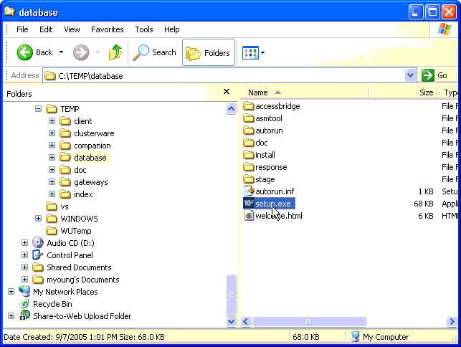

1. The Oracle Universal Installer starts.

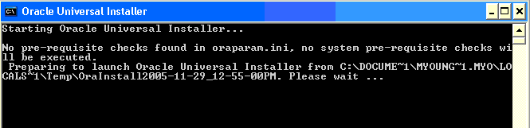

1. You will perform a basic installation with a starter database. Enter orcl for the Global Database Name and oracle for the Database Password and Confirm Password. Then click **Next**.

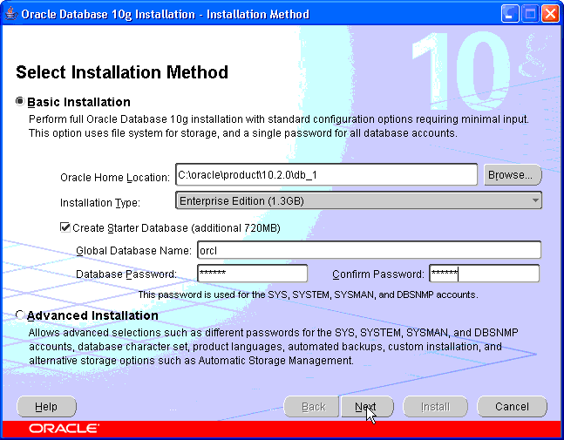

1. The installer now verifies that the system meets all the minimum requirements for installing and configuring the chosen product. Please correct any reported errors (warnings are OK) before continuing. When the check successfully completes (with or without warnings), click **Next**.

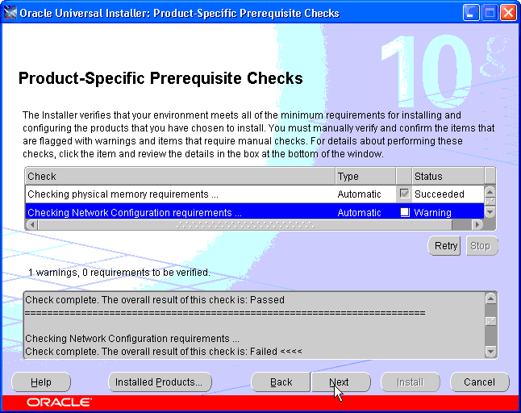

1. If you received any warnings, you can proceed. Click **Yes**.

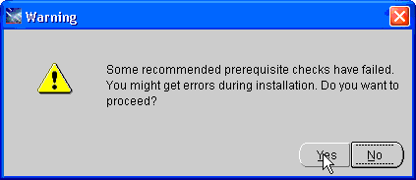

1. Review the Summary window to verify what is to be installed. Then, click **Install**

<http://www.oracle.com/webfolder/technetwork/tutorials/obe/db/10g/r2/prod/install/wininst/images/install06.gif>

1. The progress window appears

<http://www.oracle.com/webfolder/technetwork/tutorials/obe/db/10g/r2/prod/install/wininst/images/install07.gif>

1. The Configuration Assistants window appears

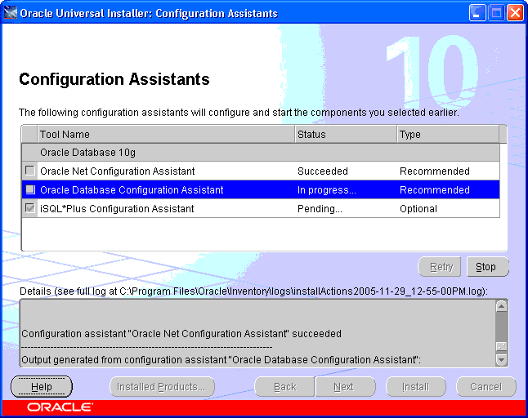

1. Your database is now being created

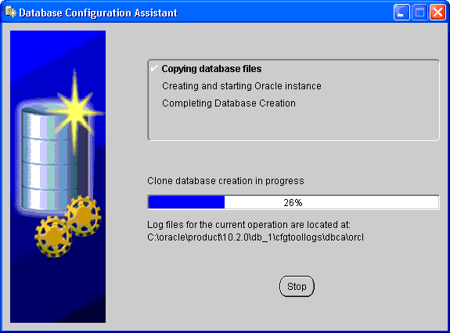

1. When the database has been created, you can unlock the users you want to use. Click **Password Management**

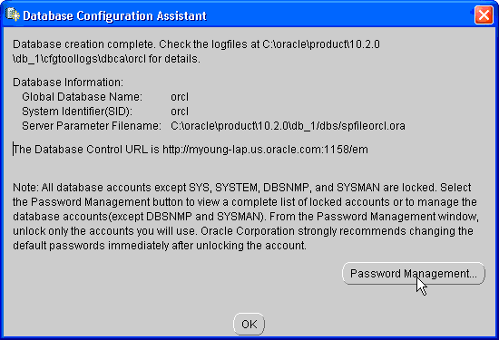

1. Unlock **SH**, **OE** and **HR** users by clicking on the check mark in the Lock Account? column. Enter the same name as the user in the New Password and Confirm Password fields. For example, to unlock **SH** user, enter SH in the New Password and Confirm Password fields. Then, click **OK.**

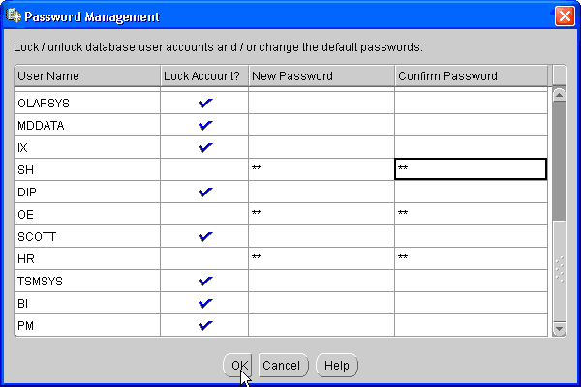

1. Click **Exit**.

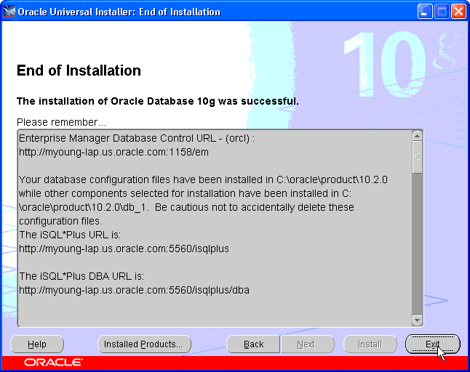

**Post Installation Tasks**

For additional functionality within DB Control, functionality such as starting and stopping the database, an operating system user must belong to the ORA_DBA group. An existing user can be used or a new user can be created. This topic shows you how to create the operating system user oracle and make the user part of the ORA_DBA group:

**Note**: The following steps outlined were done in a Windows XP environment. The steps will be slightly different in a Windows NT or 2000 environment.

|  |  |
| --- | --- |
| **1** | **Start** **> Settings >** **Control Panel**. Select **Administrative Tools**. |

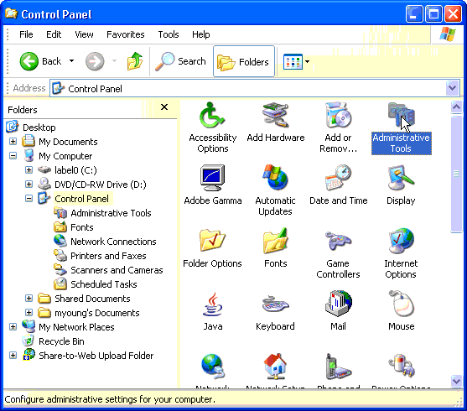

2**.Select** **Computer Management**

**Testing Your Installation**

To test that your installation completed successfully, perform the following:

|  |
| --- |
| When you click exit from the previous section, a browser opens and the Database Control URL is already launched. If this does not happen, open a browser and enter the following URL:  1.**Error! Hyperlink reference not valid.**  Enter system as the User Name and oracle as the Password and click **Login**. |

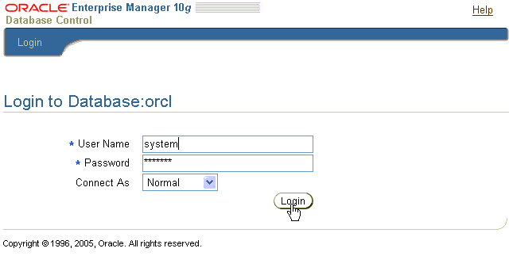

**2.** The Licensing window appears. Scroll to the bottom and click **I agree.**

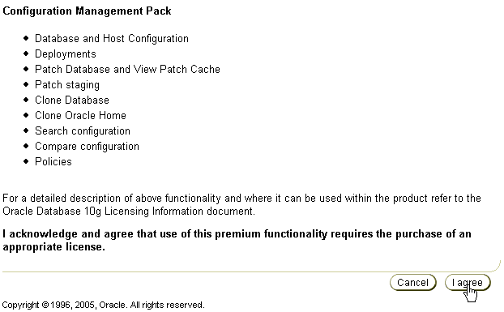

**3.** The Database Control Home Page appears. Your Installation was successful.

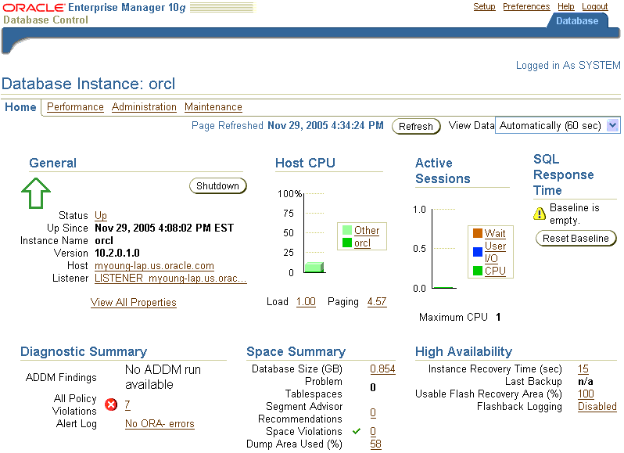

11

**LAB EXEPERIMENT NO.1**

**AIM:**TO STUDY THE BASIC DDL & DML COMMNADS.

DATA DEFINITION LANGUAGE

A data definition language (DDL) is a computer language used to create and modify the structure of database objects in a database. These database objects include views, schemas, tables, indexes, etc.   
This term is also known as data description language in some contexts, as it describes the fields and records in a database table.

Various commands of DDL are as follows:

**CREATE TABLE COMMAND:**

This command is used to creates a new table, a view of a table, or other object in database.

**SYNTAX:** CREATE TABLE tablename (Column 1 datatype(size),Column 2 datatype(size). . . . . .);

**EXAMPLE:**

create table cse_students (name char(25),rollno int ,branch char(25), contact int)

Capture.PNG

**DROP COMMAND:**

This command willdeletes an entire table, a view of a table or other object in the database.

**SYNTAX** :for deleting whole table:DROP TABLE tablename;

**EXAMPLE**: drop table nit_students

table not present.PNG

**SYNTAX** :for deleting particular column in a table:

ALTER TABLE tablename DROP COLUMN columnname;

**EXAMPLE:** alter table students drop column address

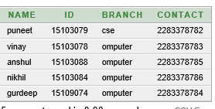

**RENAME COMMAND:**

This command is used to change the name of table or to change the name of a particular column.

**SYNTAX**: for renaming table:

RENAME old_tablename to new_tablename;

**EXAMPLE:** rename cse_students to students

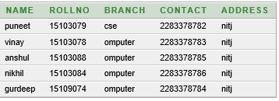

**SYNTAX** :for renaming column:

ALTER TABLE tablenameRENAME COLUMNold_columnname to new_columnname;

**EXAMPLE:** alter table students rename column rollno to id

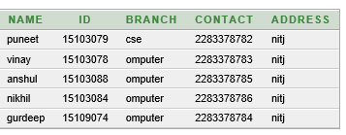

**ALTER Table Command:**

This command is used tomodifies an existing database object, such as a table.

ADDING New Columns:

**SYNTAX:**ALTER TABLE table_nameADD(Column_name1 datatype(size), . . . . . . .);

**EXAMPLE:** alter table cse_students add(address varchar(30))

select * from cse_students

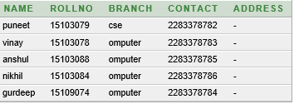

**MODIFYING Existing Table:**

This command is used to change the datatype and size of the column of table.

**SYNTAX:**ALTER TABLE table_name MODIFY (column_name1 newdatatype (new_size);

**EXAMPLE**: alter table cse_students modify (address char(20))

select * from cse_students

desc cse_students

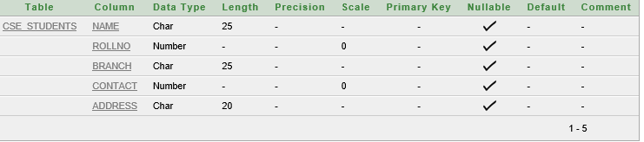

**TRUNCATE Command:**

This command is used to remove all records from a table, including all spaces allocated for the records are removed.

**SYNTAX:**TRUNCATE TABLE table_name;

**EXAMPLE:**Creating table from another Table:

**SYNYAX:**CREATE TABLE newTable_name (column_nmae1, column_name2) AS SELECT column_name1,column_name2 from table_name;

**EXAMPLE:** create table nit_students (name1,rollno1,branch1,contact1) as select name,rollno,branch,contact from cse_students

select * from nit_students

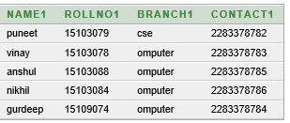

**DATA MANIPULATION LANGUAGE**

A data manipulation language is a language that enables users to access or manipulate data as organized by the appropriate data model. The type of access are:

Retrieval of information stored in the database

Insertion of new information into the database

Deletion of information from the database

Modification of information stored in the database

Various commands under DML are:

**INSERT:** This command is used to insert data into rows of table.

**SYNTAX:** INSERT INTO table_name(column_name1,column_name2,. . . .) VALUES ( Expresssion1,Expression2,. . . .)

**EXAMPLE:** insert into cse_students (name,rollno ,branch, contact) values ('puneet',15103079,'cse',2283378782)

select* from cse_students

select without condition.PNG

**UPDATE Command:** The UPDATE command is used to change or modify data values in a table and UPDATE command can Update all the rows from the table or a set of rows from the table.

**SYNTAX**: for updating all rows of column:

UPDATE table_name SET column_name=Expression;

**EXAMPLE:** update cse_students set branch='omputer'

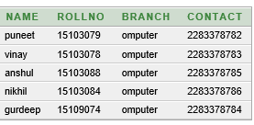

**SYNTAX for updating particular row:**

UPDATE table_name SET column_name=Expression WHERE condition(column_name)=Expression;

**EXAMPLE:**

update cse_students set branch='cse' where rollno=15103079

select * from cse_students

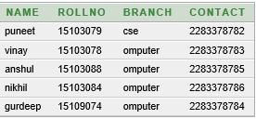

**SELECT Command:**

Once data has been inserted into a table, the next most logical operation would be to view what has been inserted. The SELECT SQL verb is used to achieve this.

**SYNTAX** : to view whole table:

SELECT * FROM table_name;

**EXAMPLE:** select * from nit_students

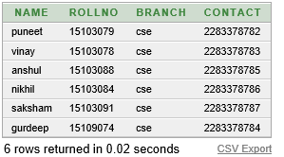

**SYNTAX**: to view particular rows:

SELECT * FROM table_name WHERE column_name=Expression;

**EXAMPLE:** select * from cse_students where name='puneet'

select with condition.PNG

**Sorting Data**:The Rows retrieved from the table will be sorted in either**Ascending(ASC)**or**Descending(DESC)**order depending on the condition specified in select statement, the Keyword has used **ORDER BY.**

**SYNTAX:** SELECT * FROM table_name ORDER BY column_name ASC/DESC;

**EXAMPLE:** select * from nit_students order by rollno1 asc

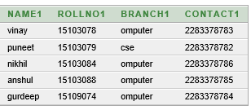

select * from nit_students order by rollno1 desc

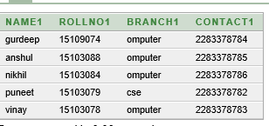

**DELETE Command:**The DELETE command can remove all the rows from the table or a set of rows from the table.

**SYNTAX** :for deleting all rows from table:

DELETE FROM table_name;

**EXAMPLE:** delete from cse_students

**SYNTAX**: for deleting particular row:

DELETE FROM table_name WHERE column_name=Expression;

**EXAMPLE:** delete from cse_students where rollno=15103091

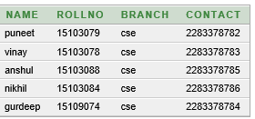

**DESCRIBE:**This is an Oracle **command** used to **describe** the structure of objects within a given database.

**SYNTAX:** DESC table_name;

**EXAMPLE:** desc cse_students



**LAB EXEPERIMENT NO.2**

**AIM:** use of more database commands

**LIKE-PREDIACTE:**This is used for pattern matching

SYNTAX: select * from table_name where name like ‘ba_%’ or ‘ba%’

EXAMPLE_1: select * from students where name like 'ch%'

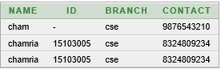

EXAMPLE_2: select * from students where name like '_h%'or name like '_a%'

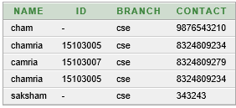

**IN**: This is used for for given a tuple for an entities whose values of any particular attribute is from given values

SYNTAX:select * from table_name where city IN(jalandhar,chandigarh)

EXAMPLE: select * from students where contact IN(8324809279,8324809234)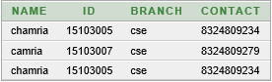

**BETWEEN:** This is used for for given a tuple for an entities whose values of any particular attribute is from a given range

SYNTAX:select * from table_name where rollno BETWEEN 10 and 20 /*both included*/

EXAMPLE: select * from students where id between 15103005 and 15103079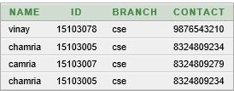

**GROUP FUNCION(aggregate fxn):**

**SYNTAX:**select group_fxn(attribute_value) from table_name

EXAMPLE_1: select AVG(id) from students

avg.PNG

EXAMPLE_2: select MIN(id) from students

min.PNG

EXAMPLE_3: select MAX(id) from students

max.PNG

EXAMPLE_4: select SUM(id) from students

sum.PNG

EXAMPLE_5: select count(*) from students

count2.JPG

EXAMPLE_6: select count(id) from students

count.PNG

**NUMERIC FUNCTION**:

SYNATX:select numeric_fxn(values) from table_name

EXAMPLE_1: select ABS(id) from students

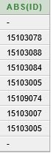

EXAMPLE_2: select power(id,2) from students

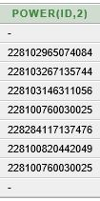

EXAMPLE_3: select round(id,10) from students

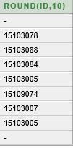

EXAMPLE_4: select sqrt(id) from students

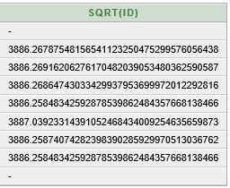

**DUAL:**Dual is small work table which consist of only one row and column and contain the value of X into that column

SYNTAX:select 3*5 from dual/*we can perform arthematic operation direct on it*/

dual.JPG

EXAMPLE:select * from dual

dummy.JPG

**LAB EXEPERIMENT NO.4**

**AIM:** To learn the use of string function

**LOWER_FUNCTION:**

SYNTAX:select lower(attribute) from table_name  
EXAMPLE: select lower(name) from students

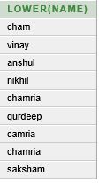

**UPPER_FUNCTION():**

SYNATX: select upper(attribute) from table_name

EXAMPLE: select upper(name) from students

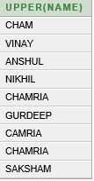

**LENGTH_FUNCTION():**

**SYNTAX:**select length(attribute) from table_name

EXAMPLE: select length(name) from students

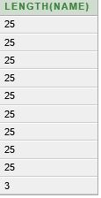

**INITCAP_FUNCTION():**convert first letter in uppercase

**SYNTAX:**select INITCAP(attribute) from table_name

EXAMPLE: select initcap (name) from students

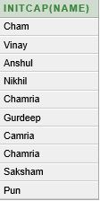

**LTRIM_FUNCTION():**

**SYNTAX:**select LTRIM(attribute,trimming_character) from table_name

EXAMPLE: select LTRIM(name,'cha') from students

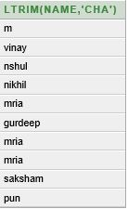

**RTRIM_FUNCION():**

**SYNTAX:**select RTRIM(attribute,trimming_character) from table_name

EXAMPLE: select RTRIM(name,'n') from students

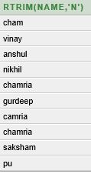

**LPAD_FUNCTION():**

**SYNTAX:**select LPAD(attribute,size_of_padding,character_fill_padding)

EXAMPLE: select LPAD(name,25,'*') from students

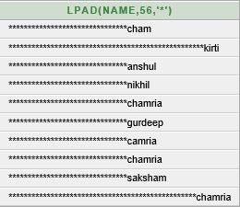

**RPAD_FUNCTION():**

**SYNTAX:**select RPAD(attribute,size_of_padding,character_fill_padding)

EXAMPLE: select RPAD(name,25,'*') from students

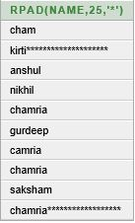

**SUBSTR_FUNCTION():**

**SYNTAX:**select SUBSTR(attribute_name,start_character_number.,number of character) from table_name

EXAMPLE**:** select SUBSTR(name,2,4) from students

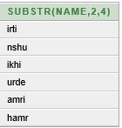

**LAB EXEPERIMENT NO.6**

**AIM:** use of various type of key

**PRIMARY KEY:**

**TYPE_1:**

**SYNTAX:** CREATE TABLE tablename (Column 1 datatype(size) primary key,Column 2 datatype(size). . . . . .);

**EXAMPLE:** create table employees (emp_id int primary key,name varchar(20),designation varchar(30))

insert into employees (emp_id,name,designation) values (123,'puneet','manager')

select * from employees

keyinsert.JPG

insert into employees (emp_id,name,designation) values (123,'nikhil','submanager')

violet.JPG

insert into employees (emp_id,name,designation) values (124,NULL,'submanager')

select * from employees

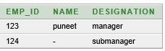

insert into employees (emp_id,name,designation) values (NULL,'nikhil','submanager')

nullpri.JPG

**TYPE_2:**form any primary key after declare all the attributes

**SYNTAX:** CREATE TABLE tablename (Column 1 datatype(size) ,Column 2 datatype(size). . . . . .,constraint xyz primary key(attribute_name)/primary key(attribute_name));

**EXAMPLE:** create table employees_1 (emp_id int ,name varchar(20),designation varchar(30),constraint xyz primary key(emp_id))

123.JPG

**TYPE_3:**make primary key of previously exist table

**SYNTAX:** alter table table_name add primary key (attribute)

**EXAMPLE:** alter table student_79 add primary key (name1)

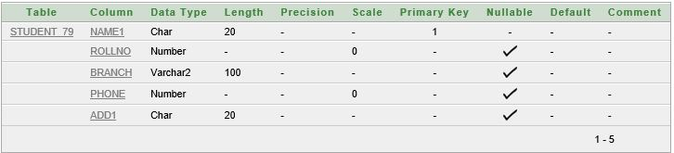

**DROP PRIMARY KEY():**

**SYNTAX:**alter table table_name drop primary key

**EXAMPLE:** alter table student_79 drop primary key

dropprimary.JPG

**UNIQUE KEY:**

**TYPE_1:**

**SYNTAX:** CREATE TABLE tablename (Column 1 datatype(size) unique,Column 2 datatype(size) unique. . . . . .);

**EXAMPLE:** create table employees_6 (emp_id int unique,name varchar(20) unique,designation varchar(30))

insert into employees_6 (emp_id,name,designation) values (123,'puneet','manager')

select * from employees_6

keyinsert.JPG

insert into employees_6 (emp_id,name,designation) values (123,'nikhil','submanager')

violet.JPG

insert into employees_6 (emp_id,name,designation) values (124,NULL,'submanager')

select * from employees_6



insert into employees_6 (emp_id,name,designation) values (null,'anshul','submanager')

select * from employees_6

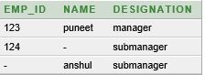

**TYPE_2:**form any unique key after declare all the attributes

**SYNTAX:** CREATE TABLE tablename (Column 1 datatype(size) ,Column 2 datatype(size). . . . . .,constraint xyz unique(attribute_name)/unique(attribute_name));

**EXAMPLE:** create table employees_7 (emp_id int ,name varchar(20),designation varchar(30),constraint asd unique(emp_id)/unique(emp_id))

123.JPG

**TYPE_3:**make unique key of previously exist table

**SYNTAX:** alter table table_name add unique(attribute)

**EXAMPLE:** alter table student_79 add unique (name1)

ater.JPG

**DROP UNIQUE KEY():**

**SYNTAX:**alter table table_name drop unique (unique_key _name)

**EXAMPLE:** alter table student_79 drop unique(name1)

dropprimary.JPG

**FOREIGN_KEY():**

**TYPE_1:**

**SYNTAX:** CREATE TABLE child_tablename (Column 1 datatype(size) primary key,Column 2 datatype(size). . . . . .,foreign key (column_name),references parent_table_anme);

**EXAMPLE:** create table employees (emp_id int primary key,name varchar(20),designation varchar(30))